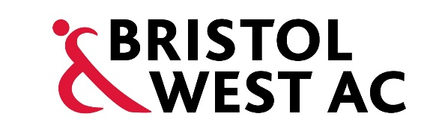

**Track Etiquette**

* The track is a shared space. Please **respect** others and understand that every individual may train in their own way and to their own ability.
* If you are a runner looking to overtake another athlete or group, you should do so by calling **“track”** to alert others. Ensure you do this at the earliest possible time and only overtake if it is safe and possible to do so. Otherwise slow down and wait for a clear opportunity to go round.
* At the point of finishing your rep/effort ensure you are aware of your surroundings and either move into a recovery lane or onto the infield, whichever is safest. Do not just come to a stop in lanes 1 or 2.
* All water bottles and bags should be kept off the track.
* No ear phones or headphones to be worn on the track.
* Please use **appropriate** behaviour and language at all times.
* Please do not leave litter, spit or leave chewing gum on the track for others to clear up. Be mindful that athletes may sit in the outside lanes or the infield around the start/finish area.
* **No smoking or vaping** is allowed on the track, infield or surrounding areas inside the barriers.
* Clothing and Kit – Appropriate training gear should be worn at all times, in order to safeguard yourself and others using the track. **Please be especially mindful on days when junior athletes are also using the track.**
* Do not cross the track or jump areas at any time without looking **both ways.**
* Do not play in the jump pits during training or races.
* Do not sit on the steeplechase bars or climb the surrounding fences.
* Courtesy and respect should always be thought about when using the facilities. The club has a **code of conduct** for athletes, coaches and spectators and expect these to be followed at all times.